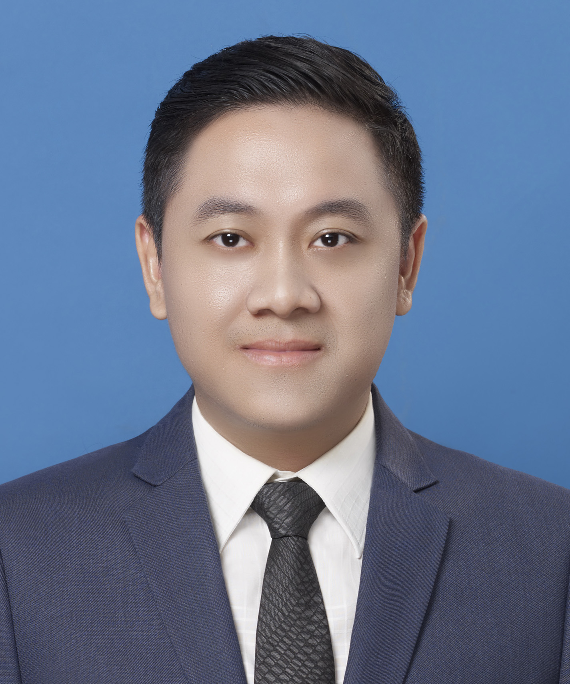
Wittawat Pawpraseart
Bangken, Bangkok 10220 Thailand
Mobile: (668) 7561-1045
E-mail: wittawatpawpraseart@gmail.com

INTERESTED JOB FUNCTION

Facility Engineer
Project Engineer
Business Development Officer
Financial Analyst
Production Manager

PERSONAL DATA

Birth Date | May 18, 1983 (32 years old)
Marital Status | Married
Height : Weight | 176 cm. : 75 kg.
Birth Place | Bangkok, Thailand

WORK EXPERIENCE

Facility Engineer (Jan 2014-Present)
Chevron Thailand Exploration and Production: Bangkok, Thailand
- Develop process monitoring tool to monitor process condition and identify parameter to track equipment efficiency. I could successfully developed pipeline pressure monitoring tool to monitor wax accumulation in pipeline so as to optimize pigging scheduling. Moreover I could completely reproduce HMI monitors for process condition monitoring in onshore-office by using PI ProcessBook Program.
- Ensure the accuracy of allocation factor and well testing. I could solve the problem about design of equipment & instrument (related to well testing) and well test procedure. Then the accuracy of gas and liquid hydrocarbon allocation factor was improved.
- Monitor production efficiency. I could successfully develop the system to forecast production efficiency and also initiate OEE (Overall Equipment Effectiveness) implementation into oil and gas business.
- Optimize production from existing wells capacity and facilities capacity to ensure that the capacity is available to meet business plans. Assist in the identification of opportunities to move resources to reserves
- Identification and resolution of bottlenecks, excess capacity and other potential constraints (e.g., HES/ compliance)
- Make the integrated “Big Picture” full life asset program visible to the Business Unit
- Provide a framework for enhanced communication among multiple disciplines

Lead Engineer-Vinyl Chain Technology (Apr 2013-Dec 2013)
SCG Chemicals Co., Ltd: Rayong, Thailand
- Interface with responsible project personnel to obtain periodic status updates of budget, progress, forecasts, schedule and issues. I had a chance to take a role of Project controller and Project coordinator for PVC paste resin capacity expansion project, budget 180 million baht.
- Support project personnel training and build people competency in the area of project controls.
- Assist in the identification and resolution of project scope, budget, and schedule issues.
- Prepare detailed project cost estimations and do feasibility studies of projects.
- Perform various engineering calculations and analyses related to process design and equipment sizing and selection.
- Define process controls and develop preliminary engineering drawings such as site layouts, P&IDs and PFDs.
- Interface with equipment suppliers and vendors. Assist the manufacturing manager in coordinating equipment assembly and shop testing.
- Prepare project documentation such as invitation to bidding document, operations & maintenance manuals. Assist applied field services staff with equipment startup and troubleshooting.

Process Engineer of Process Engineering (Mar 2010-Mar 2013)
Thai Plastic and Chemicals Public Company Limited: Rayong, Thailand
- Prepare detailed project cost estimations and perform feasibility studies of projects. I took a responsibility on electrolyzer conversion project, budget 140 million baht. The project can save the operating cost around 35 million baht per year. The project could be started up smoothly with the expected performance.
- Share engineering best practice to the team. I received the award of popular vote in 2010 TPC’s technology symposium
- Perform various engineering calculations and analyses related to process design and equipment sizing and selection.
- Define process controls and develop preliminary engineering drawings such as site layouts, P&IDs and PFDs.
- Operate bench and pilot testing equipment to support new product or process development.
- Interface with equipment suppliers and vendors. Assist the manufacturing manager in coordinating equipment assembly and shop testing.
- Prepare project documentation such as invitation to bidding document, operations & maintenance manuals. Assist applied field services staff with equipment startup and troubleshooting.

Project Engineer of South Vietnam Project (Feb 2007-Feb 2010)
Thai Plastic and Chemicals Public Company Limited: Rayong, Thailand
- Support to the project team to issue the invitation to bidding document (ITB) of South Vietnam Project. ITB could be launched to contractors in 2009, completely.
- Provide information and report to achieve investment privilege and investment license in Vietnam from Vietnam Government in 2008, successfully.
- Provided the environment impact assessment document (EIA) for South Vietnam Project in 2008.
- Prepare detailed project cost estimations. The project team could provide the detailed project cost estimation of South Vietnam Project in 2008
- Perform various engineering calculations and analyses related to process design and equipment sizing and selection.
- Define process controls and develop preliminary engineering drawings such as site layouts, P&IDs and PFDs.
- Operate bench and pilot testing equipment to support new product or process development.
- Interface with equipment suppliers and vendors. Assist the manufacturing manager in coordinating equipment assembly and shop testing.
- Prepare project documentation such as invitation to bidding document, operations & maintenance manuals. Assist applied field services staff with equipment startup and troubleshooting.

Technical Engineer of Plastic Film Process (Aug 2006-Jan 2007)
Mitsui Hygiene Materials (Thailand) CO., LTD.: Rayong, Thailand
- Investigate and study information related to production yield. Analyze and propose (with report) ways to improve production yield. I could successfully reduce waste from the production to gain production yield 8.1 million baht/year.
- Coordinate with MCI R&D in new product development. I could successfully develop process condition to produce the specialty high quality film by customer requirement.
- Investigate root cause of process trouble. I could solve film dust problem that made customers rejected the products.
- Coordinate with production crews and QA/QC officers to perform trial runs.
- Coordinate with Production Engineer in revision of production formula.

Production Engineer of Plastic Film Process (Apr 2005-Jul 2006)
Mitsui Hygiene Materials (Thailand) CO., LTD.: Rayong, Thailand
- Start up the Plastic Film Plant and train operators up to 30 persons to be ready to operate the new plant.
- Provide work instruction for operating of the new plant.
- Support foreman and coordinate to maintenance team for solving process and machine trouble. I could completely solve machine problem from start up to gain production yield 8.6 million baht/year.
- Provide raw material consumption plan to ensure availability of raw material in relevant with actual demand.
- Monitor process condition and product quality. Propose improved process condition to solve product quality issues.
- Perform risk assessment to Environment, Health and Safety Committee.

TRAINING EXPERIENCE

Production Skill | Engineering Skill | Others
- TPM: Autonomous Maintenance  - Loss Prevention Program  - PM Analysis  - Incident Investigation Cascade Training  - Water Pollution Supervisor  - Cost Reduction by Increasing of Steam System Efficiency  - Best Practices for Utility & Wastewater Pumping System  - Acceptance Sampling Plan  - Pokayoke  - Internal Auditor ISO14001:2004  - Productivity Measurement  - Visual Control System  - Operation of Overhead Crane  - Learning of Breathable Film Process for Preparation of Starting up (Japan)  - Effective Problem Solving and Decision Making | - Concern Points in Preparation of Contract  - Internal Floating Roof and Aluminum Dome Roof  - Quantitative Risk Assessment (QRA)  - Introduction to Scale-up of Chemical Processes  - Water Reclamation Technology  - Biology of Wastewater  - Improve Engineering Efficiency & Reduce Overall Costs  - Modeling Chemical Process Using Process Simulation  - Corrosion Form  - Invitation to Bidding Preparation | - Project Management  - TPM Promoter  - Coaching Program  - Abridge Business Concept Program  - Systems Thinking  - Improvement of Leader Skill  - Basic Fire Fighting

EDUCATION

Year 2009-2011 National Institute of Development Administration (NIDA)
Master of Business Administration, Finance, GPA: 3.63
Achievement: President of student of The Flexible MBA 18

Year 2001-2005 Kasetsart University
Bachelor of Chemical Engineering, GPA: 3.12
Achievement: Third Runner-up in KU. Folksong Live Music Awards 2002

Year 1995-2001 Nawamin Trachuthid Bangkok School
Science-Math program GPA: 3.63
Achievement: Second Runner-up in Mathematics Competition
Second Class Honor of GPA in Math-Science Program of M.4
Honorable Mention of Debate Competition

SKILLS

Computer skills Engineering related programs: PIPESIM, PI ProcessBook, Aspen, MATLAB
Office and Utility programs: Microsoft Excel, Power Point, Visio, Word, Photoshop
Language Skills Thai (Fluent), English (Fluent)

CURRENT PAY AND BENEFITS PACKAGE

Salary: 122,790 Bath/month
Housing Reimburse: 16,230 Bath/month
Bonus: 2 Months/year

Expected Salary Negotiable

REFERENCES

Mr. Dave Comstock
Position: Surface Equipment Reliability and Integrity Process Advisor
Company: Chevron Thailand Exploration and Production
Mobile: (669) 3134-9940

